Q1) Write a C program to check whether a number is a multiple of 3. If it is then

print “This number is multiple of 3”, otherwise print “This number is not multiple

of 3”.

**Source Code**

#include <stdio.h>

int main(){

int num;

printf("Enter any number: ");

scanf("%d", &num);

if(num%3==0)

printf("This number is multiple of 3");

else

printf("This number is not multiple of 3");

return 0;

}

**OUTPUT**

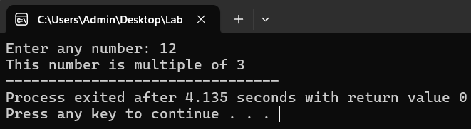

**FLOWCHART**

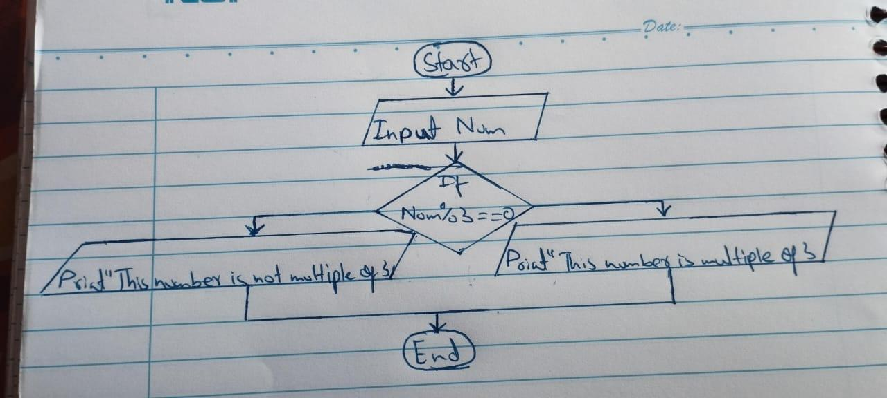

Q2) Create a calculator asking for operator (+ or – or * or /) and operands and

performs calculation according to the user input using switch statement.

**SOURCE CODE**

int main(){

char op;

float num1 , num2, ans;

printf("Enter any two numbers: ");

scanf("%f%f", &num1, &num2);

printf("Enter any operator (+ or – or * or /): ");

scanf(" %c", &op);

if(op=='+' || op=='-' || op=='*' || op=='/')

{

switch (op)

{

case '+':

ans=num1+num2;

break;

case '-':

ans=num1-num2;

break;

case '*':

ans=num1*num2;

break;

default:

ans=num1/num2;

}

printf("%.2f %c %.2f = %.2f", num1, op, num2, ans);

}

else

printf("Invalid operator!");

return 0;

}

**OUTPUT**

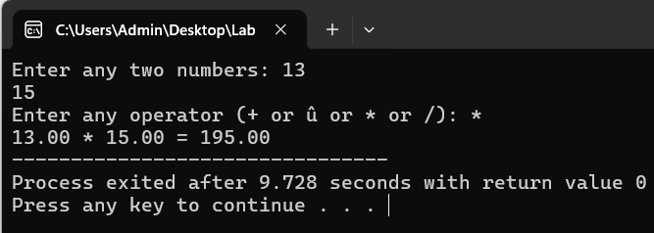

**FLOWCHART**

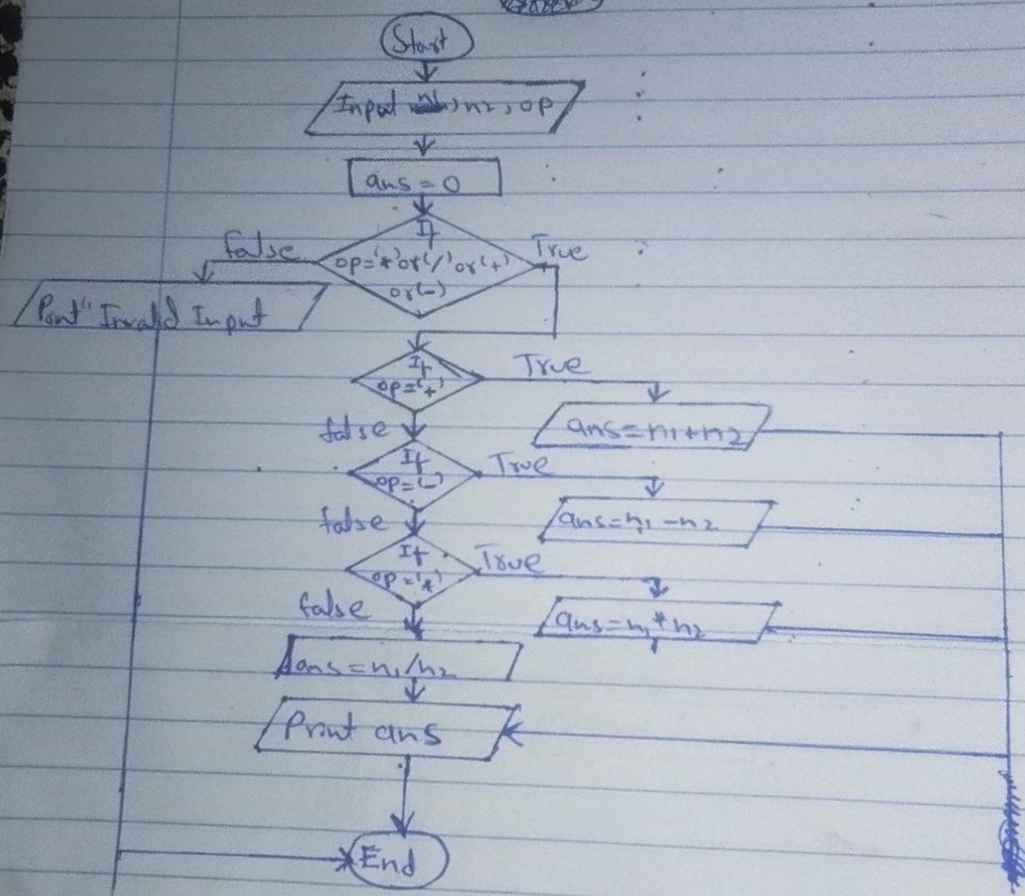

Q2) Write a C program to input a character from the user and check whether the

given character is a small alphabet, capital alphabet, digit, or special character,

using if else.

**SOURCE CODE**

#include<stdio.h>

int main(){

char ch;

printf("Enter any character: ");

scanf("%c", &ch);

if(ch>='a' && ch<='z')

printf("%c is a small alphabet.", ch);

else if(ch>='A' && ch<='B')

printf("%c is a capital alphabet.", ch);

else if(ch>='0' && ch<='9')

printf("%c is a digit.", ch);

else

printf("%c is a special character", ch);

return 0;

}

**OUTPUT**

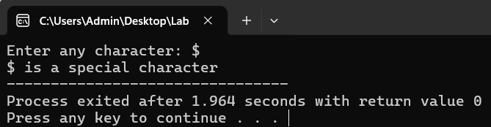

**FLOWCHART**

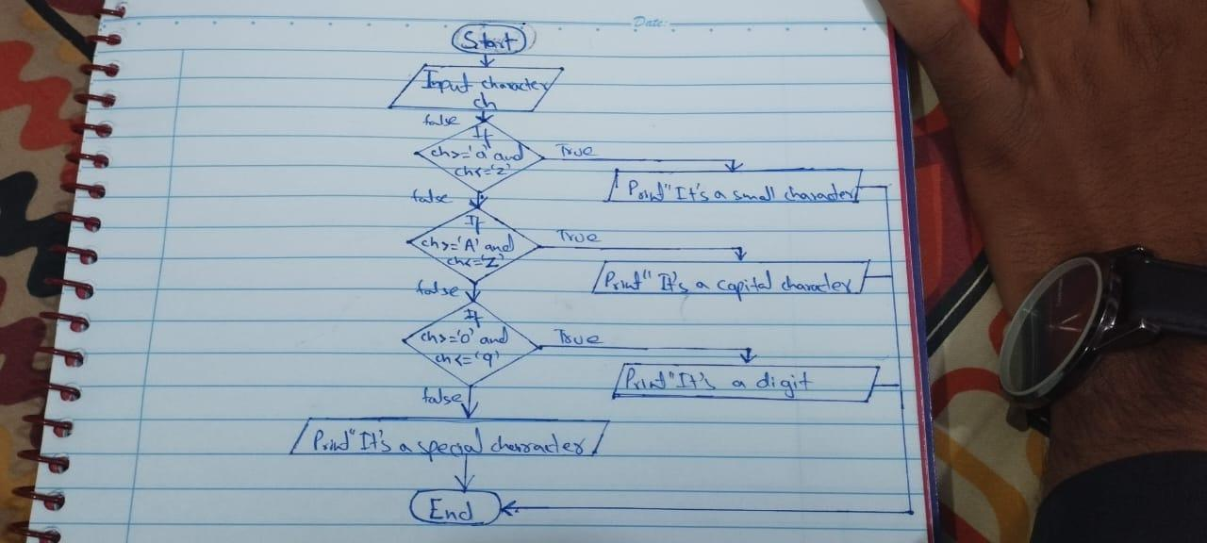

Q4) An online shopping store is providing discounts on the items due to the Eid. If

the cost of items is less than 2000 it will give a discount up to 5%. If the cost of

shopping is 2000 to 4000, a 10% discount will be applied. If the cost of

shopping is 4000 to 6000, a 20% discount will be applied. If it's more than 6000

then a 35% discount will be applied to the cost of shopping. Print the actual

amount, saved amount and the amount after discount. The Minimum amount

eligible for a discount is 500.

**SOURCE CODE**

#include <stdio.h>

int main(){

float cost, disc=0;

printf("Enter the cost: ");

scanf("%f", &cost);

if(cost>=500 && cost<2000)

disc=0.05;

else if(cost>=2000 && cost<=4000)

disc=0.1;

else if(cost>4000 && cost<=6000)

disc=0.2;

else if(cost>6000)

disc=0.35;

else

printf("Very low cost for a discount!\n");

printf("Actual amount: %.2f\nSaved amount: %.2f\nAmount after discount: %.2f", cost, cost*disc, cost*(1-disc));

return 0;

}

**OUTPUT**

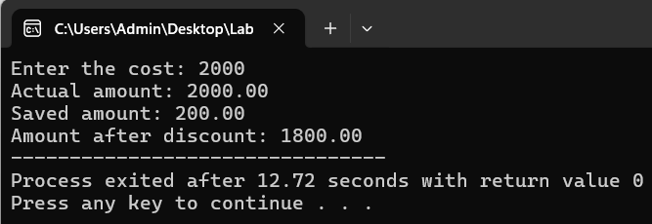

**FLOWCHART**

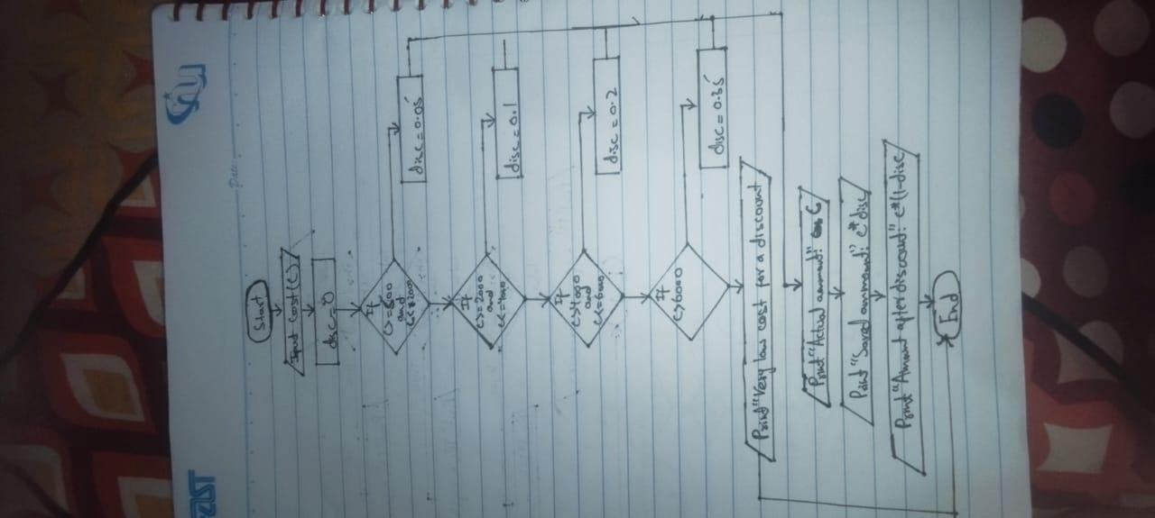

Q5) Write a program in C to calculate and print the Electricity bill of a given

customer. The customer id., name and unit consumed by the user should be

taken from the keyboard and display the total amount to pay to the customer.

The charges are as follow:

|  |  |
| --- | --- |
| Unit | Charge/Unit |
| Up to 199 | @16.20 |
| 200 and above but less than 300 | @20.1 |
| 300 and above but less than 500 | @27.10 |
| 500 and above | @35.90 |

If the bill exceeds Rs. 18000 then a surcharge of 15% will be charged on top of the bill.

**SOURCE CODE**

#include <stdio.h>

int main(){

int C_ID;

float units_c, bill=0, p_p_unit, S_A=0;

char name;

printf("Enter your name, coustumer ID and units consumed repectively:\n");

scanf(" %c%d%f", &name, &C_ID, &units_c);

if (units_c>=0 && units_c<200)

p_p_unit=16.2;

else if(units_c>=200 && units_c<300)

p_p_unit=20.1;

else if(units_c>=300 && units_c<500)

p_p_unit=27.1;

else if(units_c>=500)

p_p_unit=35.9;

else

printf("Invalid input!!");

bill=units_c*p_p_unit;

if(bill>18000)

{

S_A=bill*0.15;

bill+=S_A;

}

printf("Coustomer ID:%d\nCustomer Name:%c\nUnits Consumed:%.2f\nAmount Charges @Rs. %.2f per unit:%.2f\nSurcharge Amount:%.2f\nNet Amount Paid by the Customer:%.2f", C_ID, name, units_c, p_p_unit, units_c*p_p_unit, S_A, bill);

return 0;

}

**OUTPUT**

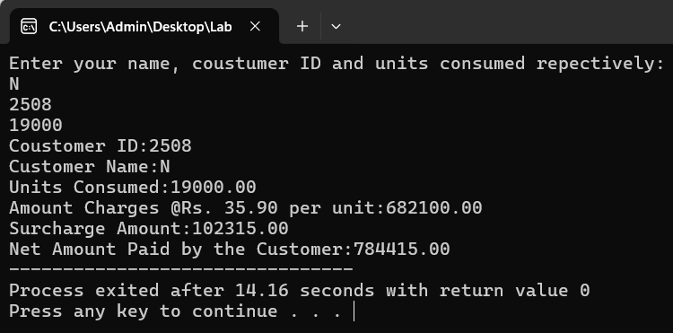

**FLOWCHART**

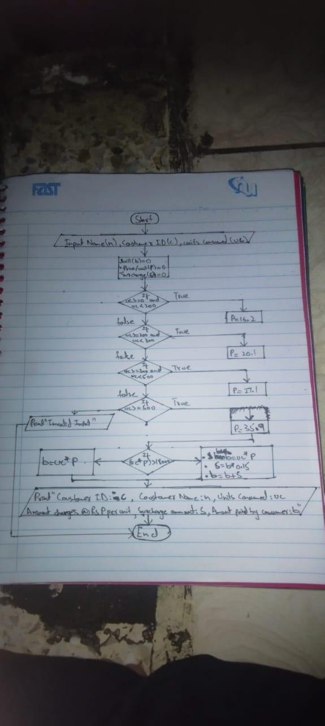

Q6) Given a positive integer denoting n, do the following:

a. If 1<=n<=9, print lowercase English words corresponding to the

numbers e.g. (one for 1, two for 2)

b. If n>9 print greater then 9

**SOURCE CODE**

**#include<stdio.h>**

**int main(){**

**int n;**

**printf("Enter any number: ");**

**scanf("%d", &n);**

**if(n>=0 && n<=9)**

**{**

**switch(n)**

**{**

**case 1:**

**printf("one");**

**break;**

**case 2:**

**printf("two");**

**break;**

**case 3:**

**printf("three");**

**break;**

**case 4:**

**printf("four");**

**break;**

**case 5:**

**printf("five");**

**break;**

**case 6:**

**printf("six");**

**break;**

**case 7:**

**printf("seven");**

**break;**

**case 8:**

**printf("eight");**

**break;**

**case 9:**

**printf("nine");**

**break;**

**default:**

**printf("Error: Number is out of the range for this case.");**

**}**

**}**

**else**

**printf("greater than 9");**

**return 0;**

**}**

**OUTPUT**

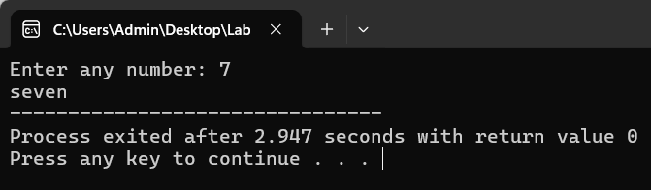

Q7) An android developer wants to design a mobile feature to control the

brightness of the mobile phone according to the surrounding light. In order to

do it he uses an ambient light sensor (for the detection of surrounding light)

which is commonly built in in all major android phones. It gives the value of

light intensity in integers. Write a C program for Light sensor value ranges from

0-1000, if it's exposed under sunshine (>500), if it's evening then (0 ~ 100),

lighting (100 to 500).

**SOURCE CODE**

#include<stdio.h>

int main(){

int light_intens;

printf("Enter intesity of surrounding light value (0-1000): ");

scanf("%d", &light_intens);

if(light_intens>=0 && light_intens<=1000)

{

if(light_intens>500 && light_intens<=1000)

printf("Sunshine detected! Adjust brightness to high.");

else if(light_intens>100 && light_intens<=500)

printf("light detected! Adjust brightness to medium.");

else

printf("Evening or Night detected! Adjust brightness to low.");

}

else

printf("Invalid input!");

return 0;

}

**OUTPUT**

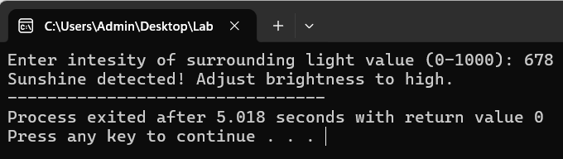

Q8) Write a program to see greetings according to time using a 24-hour format. If

the time between is 5 to 11 it should greet “Good Morning”, if time is between

12 to 18 it should greet “Good Evening”, if time between 18 to 24 it should

greet “Good Night”.

**SOURCE CODE**

#include <stdio.h>

int main(){

int hour;

printf("Enter the hour (1-24): ");

scanf("%d", &hour);

if (hour < 1 || hour > 24)

printf("Invalid input! Hour must be between 1 and 24.\n");

else {

if (hour >= 5 && hour < 12)

printf("Good Morning");

else if (hour >= 12 && hour < 18)

printf("Good Evening");

else

printf("Good Night");

}

return 0;

}

**OUTPUT**

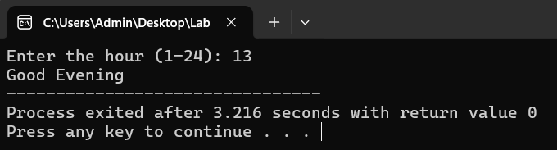

Q9) Write a program in which user enters his NTS and F.Sc marks and your

program will help student in selection of university. Based on these marks

Student will be allocated a seat at different department of different university.

a) Oxford University: IT:

a. Above 70% in Fsc. and 70 % in NTS

b. Electronics: Above 70% in Fsc. and 60 % in NTS

c. Telecommunication: Above 70% in Fsc. and 50 % in NTS

b) MIT:

a. IT: 70% - 60 % in Fsc. and 50 % in NTS

b. Chemical: 59% – 50 % in Fsc. and 50 % in NTS

c. Computer: Above 40% and below 50 % in Fsc. and 50 % in NTS

**SOURCE CODE**

#include<stdio.h>

int main(){

float Fsc, NTS;

printf("Enter your Fsc and NTS percentage respectively:\n");

scanf("%f%f", &Fsc, &NTS);

if(Fsc>40 && NTS>=50)

{

if(Fsc>70 && NTS>70)

printf("You have been allocated with a seat of IT department in Oxford University!\n");

if(Fsc>70 && NTS>60)

printf("You have been allocated with a seat of Electronics department in Oxford University!\n");

if(Fsc>70 && NTS>50)

printf("You have been allocated with a seat of Telecommunication department in Oxford University!\n");

if(Fsc>=60 && Fsc<=70 && NTS>=50)

printf("You have been allocated with a seat of IT department in MIT University!\n");

if(Fsc>=50 && Fsc<=59 && NTS>=50)

printf("You have been allocated with a seat of Chemical department in MIT University!\n");

if(Fsc>40 && Fsc<50 && NTS>=50)

printf("You have been allocated with a seat of Computer department in MIT University!\n");

}

else if(Fsc>=0 && NTS>=0)

printf("Very low percent of Fsc and NTS in order to allocate a seat to you in any department!");

else

printf("Invaid input");

return 0;

}

**OUTPUT**

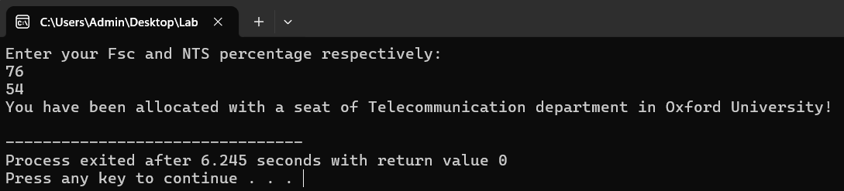

Q10) Write a C program that takes the temperature as input from the user and

prints a message based on the temperature range:

a) Temperature < 0: "Freezing weather"

b) 0 to 10: "Very cold weather"

c) 11 to 20: "Cold weather"

d) 21 to 30: "Normal temperature"

e) 31 to 40: "Hot weather"

f) 40: "Very hot weather"

**SOURCE CODE**

#include <stdio.h>

int main() {

float temperature;

printf("Enter the temperature: ");

scanf("%f", &temperature);

if (temperature<0)

printf("Freezing weather");

else if (temperature>=0 && temperature<=10)

printf("Very cold weather");

else if (temperature>=11 && temperature<=20)

printf("Cold weather");

else if (temperature>=21 && temperature<=30)

printf("Normal temperature");

else if (temperature>=31 && temperature<=40)

printf("Hot weather");

else

printf("Very hot weather");

return 0;

}

**OUTPUT**

